
For Immediate Release For More Information
September 24, 2014 Julie Huso, Executive Director
605-370-4652
jhuso@vor.net

VOR National Disability Advocate to Meet with Summerville Families,
Participate at South Carolina Association of Residential Care Homes Conference

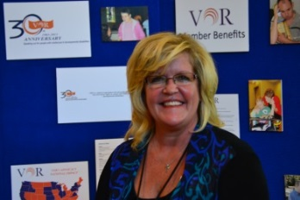
ISLE OF PALMS – Julie Huso, Executive Director of VOR, a national organization for people with intellectual and developmental disabilities, will represent VOR at the South Carolina Association of Residential Care Homes Conference on September 29, 2014.

VOR advocates for high quality care and human rights for all people with intellectual and developmental disabilities across the country. It is the only national advocacy organization that supports a full spectrum of residential care options and other supports for people with intellectual and developmental disabilities.

“We know from our national advocacy that service options are decreasing,” said Huso. “That comes as a surprise to many families and advocates, but service cuts are resulting in fewer and fewer choices, especially when it comes to specialized care provided in residential settings.”

The South Carolina Association of Residential Care Homes (http://scarch.org/) represents assisted living, residential care facilities, home care, home health and hospice groups throughout the state, providing care to individuals with disabilities and the elderly.

This will be VOR’s first opportunity to participate in the annual conference, but sees a fit between the VOR’s mission and the Association’s core principles of accountability, compassion, high integrity and respect, within standards which promote and enhance residential care.

“VOR represents individuals with profound intellectual and developmental disabilities and their families,” says Huso. “The well-being of profoundly disabled citizens is directly in the hands of their caregivers, including members of the South Carolina Association of Residential Care Homes. I look forward to meeting these care providers and thanking for their work and advocacy.”

On Tuesday, September 30 at 10:30 am at the Coastal Center's Canteen, Huso will also meet with families of residents of the Coastal Center in Summerville. Coastal Center is a licensed facility home providing specialized supports to more than 150 people with profound intellectual and developmental disabilities.

Huso, whose organization has helped families and advocates in other states, will offer an overview of some federal laws that offer individual and families certain rights.

“Families are the most effective voice for their disabled loved ones,” Huso said. “They know best. It is critical that families be on the frontlines educating legislators and state officials about the unparalleled, comprehensive and highly specialized care provided at Coastal and the State’s other Regional Center homes. These centers are a true community of residents and caring people.”
~End~

