
For More Information For Immediate Release
Tamie Hopp, 605-484-8300; thopp@vor.net November 6, 2014
VOR Director of Govt. Relations & Advocacy

Kathleen Miller, 707-838-2933; kjmillerkoch@yahoo.com
President, Parent Hospital Association -Sonoma

National Disability Advocate to Speak
on History and Future of Deinstitutionalization

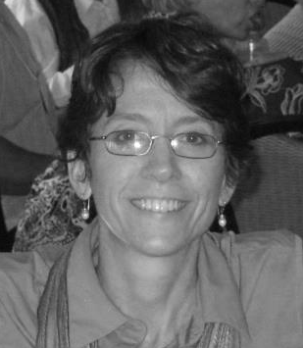
ELDRIDGE – Tamie Hopp, a national advocate for people with intellectual and developmental disabilities, will give a free presentation on the history and future of deinstitutionalization at the Sonoma Developmental Center in Eldridge on Saturday, November 8 at 10:00 am.

Hopp is the Director of Government Relations and Advocacy for VOR, a national nonprofit organization that advocates for high quality care and human rights for people with intellectual and developmental disabilities. She has been involved in disability advocacy for 19 years.

The Parent Hospital Association for Sonoma Developmental Center, which represents families and advocates and is an affiliate of VOR, is hosting the presentation.

Sonoma is a state-operated home for 430 of some of California’s most profound disabled citizens. According to the state’s website, approximately one thousand acres of land, lakes, and various structures encompass the Sonoma Developmental Center campus, including a residential campground, store/cafeteria, post office, petting farm, sports fields, swimming pool, plant nursery, and picnic areas.

Homes like Sonoma are threatened across the country, says Hopp.

“Deinstitutionalization – the closure of specialized homes like Sonoma - has been pursued in earnest for decades,” said Hopp. “While early efforts were well-placed, helping thousands of inappropriately placed individuals secure more appropriate housing and services, the pendulum has continued to swing, placing very fragile people at grave risk.”

Hopp will provide an overview of the history of deinstitutionalization, its status currently, and what role family advocates can play in the future of their loved ones’ care.

“There is no silver bullet to stop closings,” said Hopp. “I would be doing families a disservice if I promised success. However, what I can tell them is that states cannot, legally or morally, stop providing necessary services to eligible citizens. Federal law clearly recognizes the right to individual and family choice according to need.”

Proponents of closure argue that people with developmental disabilities are always served better in small settings. VOR’s members see things differently.

“Tragedies following forced deinstitutionalization are widespread and well-documented,” said Hopp. “Without question, deinstitutionalization has failed many people.”

“For 31 years, VOR has advocated that families are the most effective voice for their disabled loved ones,” Hopp said. “They know best. It is critical that families be on the frontlines educating legislators and state officials about the unparalleled, comprehensive and highly specialized care their loved ones receive.”

About VOR: VOR is a national organization that advocates for high quality care and human rights for people with intellectual and developmental disabilities. Standing up for long-term care facilities and community disability programs, VOR is dedicated to maintaining individual family choice for people with intellectual and developmental disabilities. For more information about VOR, including information about our programs and a press kit, please visit http://vor.net/about-vor.
-End-

