
For Immediate Release For More Information
October 2, 2014 Julie Huso, Executive Director
605-370-4652
jhuso@vor.net

VOR National Disability Advocate To Attend
American Health Care Association’s National Conference and Expo
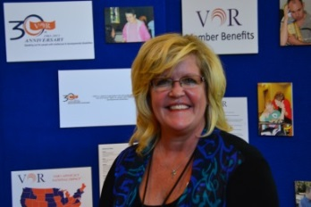
WASHINGTON, D.C. - Julie Huso, Executive Director of VOR, a national organization for people with intellectual and developmental disabilities, will attend the American Health Care Association/National Center for Assisted Living’s Convention & Expo in Washington, D.C. on October 6, 2014.

VOR advocates for high quality care and human rights for all people with intellectual and developmental disabilities across the country. The annual AHCA/NCAL event includes educational sessions, inspiring general sessions, and an interactive Expo Hall for long-term and post-acute care professionals for seniors and people will developmental disabilities.

“VOR represents many individuals with profound intellectual and developmental disabilities who receive high quality care in the private long-term care facilities represented by AHCA/NCAL,” said Huso. “As an exhibitor and participant, we get a chance to thank these providers for their compassionate and skilled care.”

Huso has served as VOR’s Executive Director for more than five years and has worked as a disability advocate for more than 25 years. VOR is the only national advocacy organization challenging a national trend in support of closing specialized homes.

“Necessary services, including specialized homes – private and publicly operated – are being closed or threatened with closure in many states,” remarked Huso. “VOR is doing all we can to prevent these closures. Opportunities to show our support to the providers who deliver this necessary care are a big part of our advocacy.”

About VOR:
VOR is a national organization that advocates for high quality care and human rights for people with intellectual and developmental disabilities. Offering community, legal, medical and educational resources for families of individuals with special needs, VOR is committed to providing help for people with disabilities. Standing up for long term care facilities and community disability programs, VOR is dedicated to maintaining individual and family choice for people with intellectual and developmental disabilities. For more information about VOR, please visit us at www.vor.net.
-End-

